Görkem Enes Bektaş
bektasgorkemenes@gmail.com
Politechnika Czestochowska

Berke Can Kaya
bluten07@gmail.com
Politechnika Czestochowska

Signal analysis and Data processing

Laboratory Class - Experiment 5

FILTERİNG
Introduction
Signals are fundamental in various fields, including sound processing, image transmission, and electronic communication systems. Mathematical methods are frequently utilized to analyze and process signals, with Fourier series being one of the most effective tools for representing periodic signals and decomposing them into their frequency components. In practical applications, signals often contain unwanted elements such as noise or irrelevant frequency components. Filtering is a crucial process that improves signal quality by isolating the desired frequency ranges and removing undesired ones.

Compulsory Tasks:

We chose a band-pass filter because band-pass filter allows signals within a specific frequency range to pass through while attenuating frequencies outside this range. Based on the provided data, the performance of the filter can be evaluated by analyzing the output-to-input amplitude ratio (Aout/Ain) as a function of frequency.
The filter achieves its peak amplitude ratio (Aout/Ain = 1) around 77 Hz to 90 Hz, indicating the central frequency band where the filter passes signals with minimal attenuation. Frequencies lower than approximately 60 Hz and higher than 120 Hz are significantly attenuated. For instance, at 5 Hz, Aout/Ain= 0, meaning the low-frequency signal is completely suppressed, and at 500 Hz, Aout/Ain=0A, indicating that high-frequency signals are also entirely blocked. The transition from the passband to the stopband is gradual, as seen in the amplitude ratios:
- At 58 Hz, Aout/Ain=0.7 (approaching the lower cutoff),
- At 120 Hz, Aout/Ain=0.5 (exiting the upper cutoff).
The filter passes frequencies primarily in the range of 60 Hz to 120 Hz, which can be considered the passband. Within this range, signals maintain a high amplitude ratio, making the filter suitable for applications that require selective transmission of frequencies in this interval. Using a band-pass filter is effective for noise suppression, eliminating unwanted low-frequency and high-frequency noise, and for signal isolation, enhancing the clarity of signals within the desired frequency band while rejecting irrelevant components.
To further evaluate the filter’s performance, it is recommended to determine the precise cutoff frequencies (f1 and f2​) where the amplitude ratio drops to 0.707 (3 dB attenuation point), providing a more accurate assessment of the passband. This filtering process can also be tested with different types of input signals, such as polyharmonic signals or square waves, to explore the filter’s behavior under various conditions.

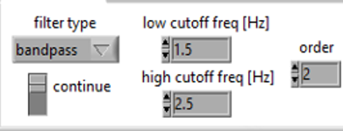
Figure 1.1 An example of our Band-pass filter

F(Hz) | A_{out}/A_{in}
5 | 0
11 | 0,01
23 | 0,05
30 | 0,1
39 | 0,2
44 | 0,3
48 | 0,4
52 | 0,5
54 | 0,6
58 | 0,7
60 | 0,8
64 | 0,9
77 | 1
90 | 1
103 | 0,9
109 | 0,8
115 | 0,7
120 | 0,6
126 | 0,5
134 | 0,4
144 | 0,3
161 | 0,2
196 | 0,1
240 | 0,05
300 | 0,02
500 | 0

- Analyze the influence of filtering (its type and settings) on polyharmonic signal composed of 3 sine waves,
When a band-pass filter is applied to the polyharmonic signal with components at 2 Hz, 12 Hz, and 75 Hz, only the frequency components within the filter's passband will be preserved, while frequencies outside this range will be attenuated.
- Low Frequency (2 Hz): The 2 Hz component is very low and typically falls within the stopband of a band-pass filter. If the band-pass filter is set to exclude frequencies around 2 Hz, this component will be completely attenuated, causing it to disappear from the signal. This will result in a smoother signal, with reduced low-frequency components.
- Mid Frequency (12 Hz): The 12 Hz component is likely to fall within the filter's passband. If the band-pass filter is set with a passband around 10 Hz to 15 Hz, the 12 Hz component will pass through unaffected and remain in the output signal. This frequency will remain intact and contribute to the preserved signal.
- High Frequency (75 Hz): The 75 Hz component is higher and may be close to the upper limit of the filter’s passband. If the band-pass filter is set to allow frequencies up to 75 Hz (for example, with an upper cutoff of 80 Hz), this component will pass through. However, if the upper cutoff frequency is set lower than 75 Hz, this component will be attenuated and removed from the signal.
When the band-pass filter is applied:
- The 12 Hz component is likely preserved, as it falls within the passband.
- The 2 Hz low-frequency component will be suppressed and removed from the signal.
- The 75 Hz high-frequency component may or may not pass, depending on the filter’s upper cutoff frequency.

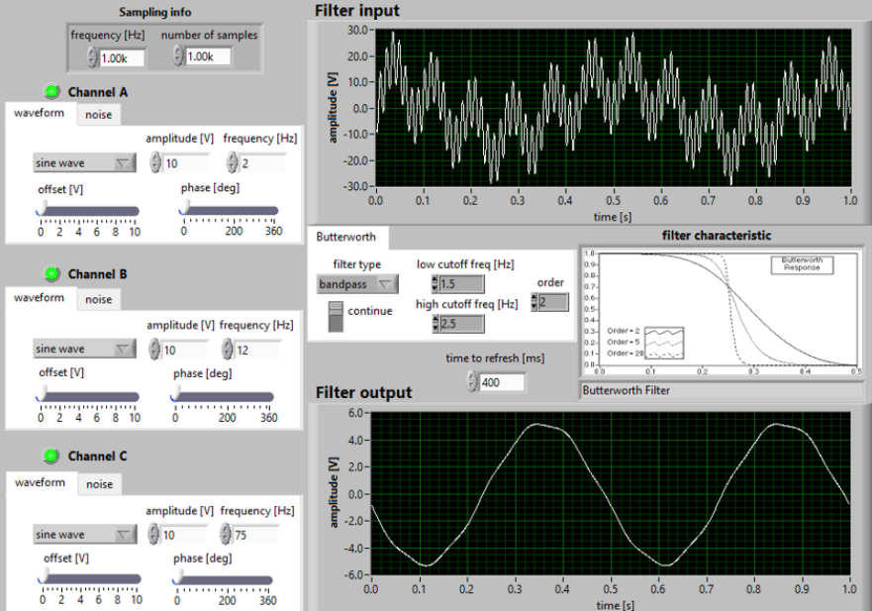
Figure 2.1 Band-pass Filter with Low Cutoff Frequency Range
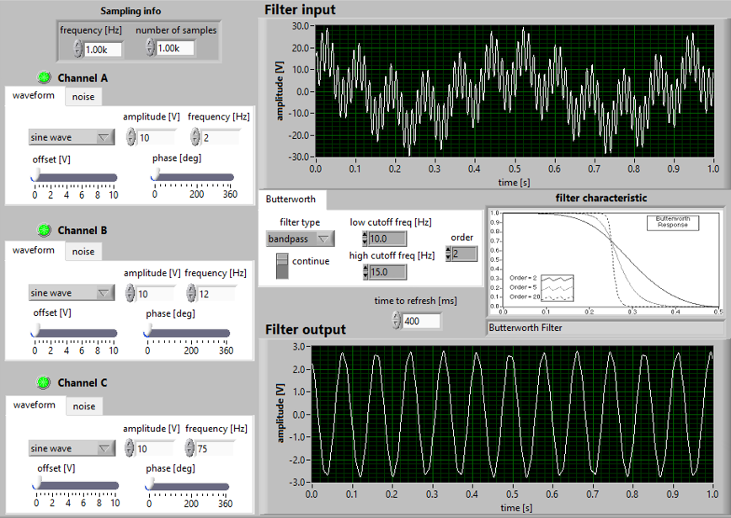
Figure 2.2 Band-pass Filter with Medium Cutoff Frequency Range
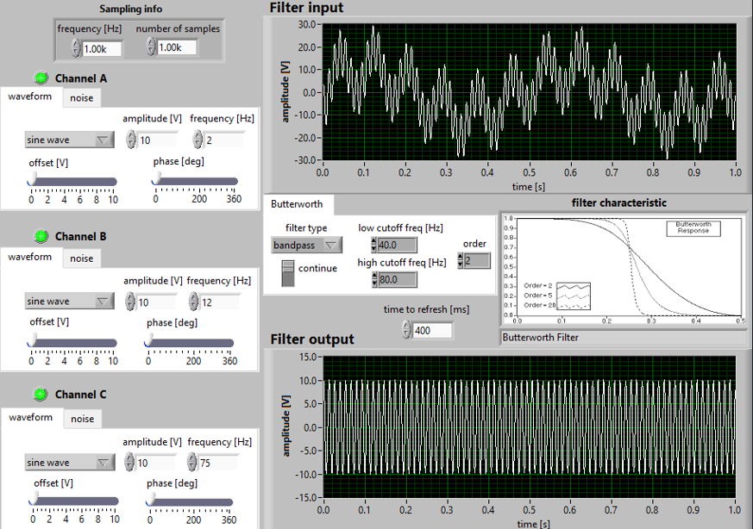
Figure 2.3 Band-pass Filter with High Cutoff Frequency Range

- Analyze the influence of the setting of a low-pass filter on the square wave filtering,We can observe that when we increase our Low Cutoff Frequency, our Filter Output looks more visible and clear compared to having low value on our Low Cutoff Frequency. So for example,when our Low Cutoff Frequency is near to maximum which is 349 Hz, it looks more clear than Low Cutoff Frequency at 100 Hz.
. 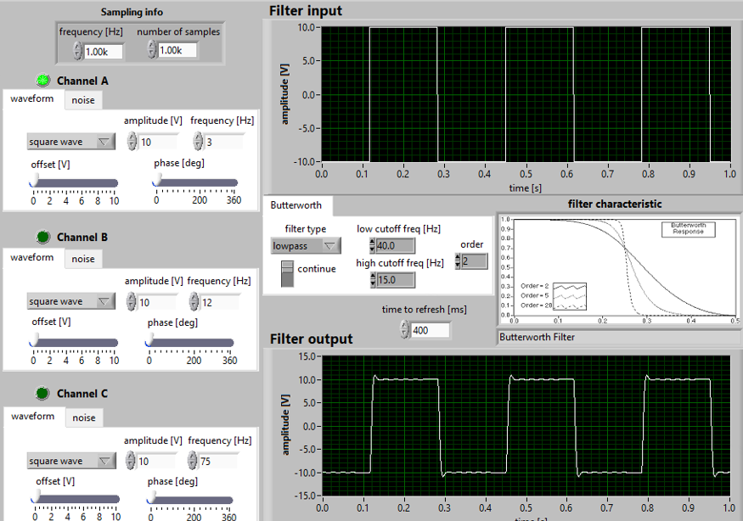
Figure 3.1 Low-pass filter with 40 Hz of Low Cutoff Frequency, Our Filter Output is not clear
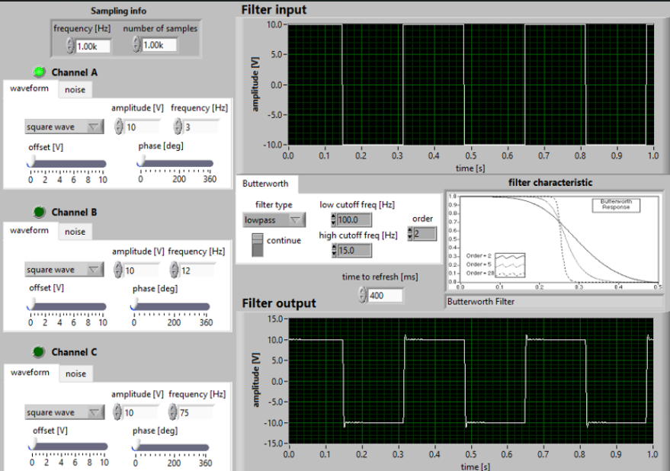
Figure 3.2 Low-pass filter with 100 Hz of Low Cutoff Frequency,
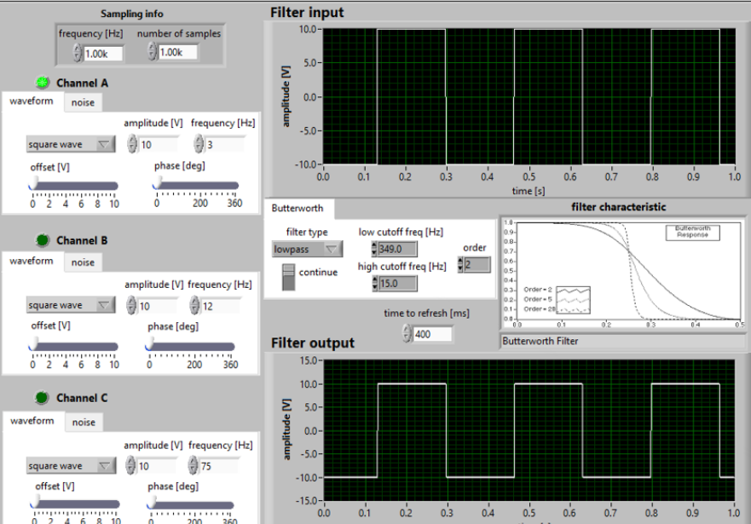
Figure 3.3 Low-pass filter with 350 Hz of Low Cutoff Frequency,
As can be seen in the figures, as the low cutoff frequency increases, the square wave at the filter output becomes more visible and recognizable. From the very noisy state in figure 1 to the almost perfect square wave in figure 3.

- Apply the band-pass filter to noise and mean removal.
In this task a sin wave is combined with a noise and we want to remove the noise and the mean value with a band pass filter. The properties of the band pass filter are to remove the high and low frequencies and to remove the mean value. To better understand the band pass filter, we have taken the amplitude of the sin wave as 4 and the s.d of the noise as 3.

Start adjusting the frequency range of the band pass filter so that the output signal is ideal. The greater the difference between the low and high cutoff frequencies and the further away from the amplitude of the sin wave, the noisier the output wave is. As Figure 4.1 shows, our range is between 1 and 20 Hz, which shows how bad our output looks. When we look at Figure 4.2, the frequency range decreases and the image looks a little better, but it is still not the perfection we want. In Figure 4.3, our frequencies are between 3-5 Hz and our output image looks exactly as we want. But if we make the values even smaller, for example 3.5-4.5, the image starts to deteriorate again.
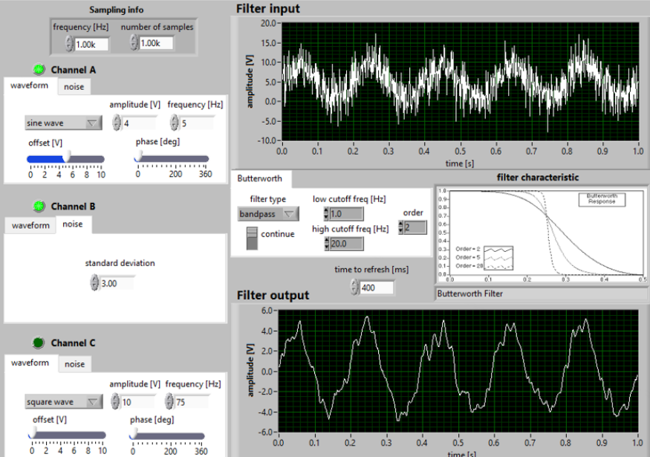
Figure 4.1 Band-pass filter with Cutoff Frequency Range between 1 and 20 Hz
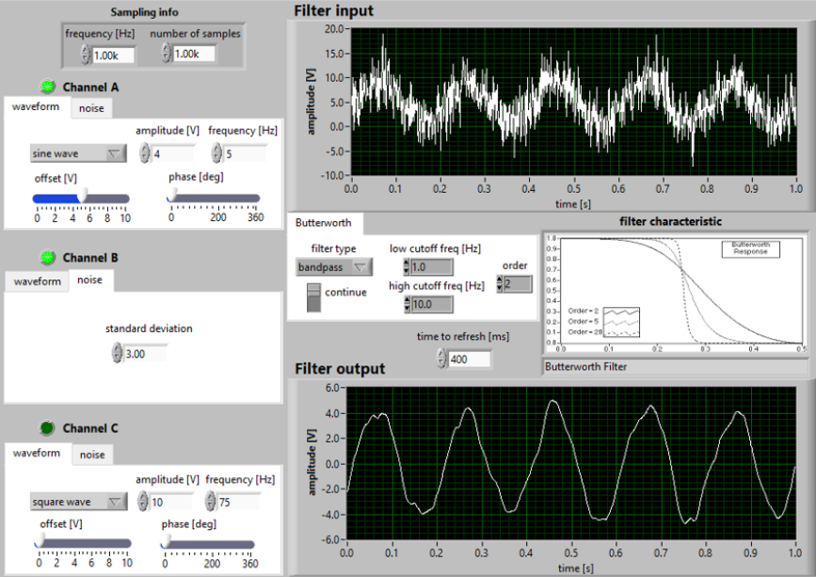
Figure 4.2 Band-pass filter with Cutoff Frequency Range between 1 and 10 Hz.
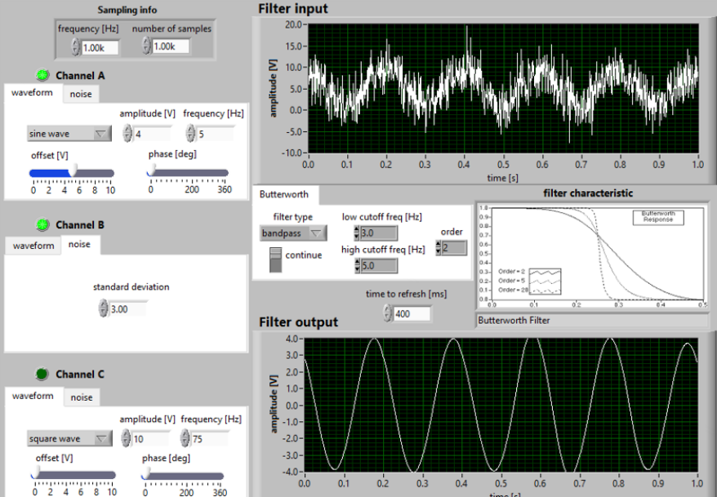
Figure 4.3 Band-pass filter with Cutoff Frequency Range between 3 and 5 Hz.

Conclusion
In this analysis, different types of filters were applied to a polyharmonic signal consisting of multiple sine waves with varying frequencies. The impact of the filtering process on the signal was evaluated with respect to the filter type and its settings.
- Band-Pass Filter: The band-pass filter effectively allowed frequency components within its passband to remain, while attenuating frequencies outside this range. For instance, lower frequency components (e.g., below the passband) and higher frequency components (e.g., above the passband) were attenuated, while the frequencies within the desired range were preserved. This selective filtering ensured that only the relevant frequency components of the signal were retained, depending on the specific frequency range chosen for the filter.
- Low-Pass and High-Pass Filters: The low-pass filter successfully removed higher-frequency components, resulting in a smoother signal with only the lower-frequency components remaining. Similarly, the high-pass filter effectively removed low-frequency components, preserving the higher-frequency parts of the signal. The choice of cutoff frequencies in both cases was crucial in determining which parts of the signal were retained or suppressed.
- Noise and Mean Removal: When applying the band-pass filter for noise and mean removal, it was observed that the filter could effectively remove unwanted frequencies outside the desired range, while preserving the main signal components. This made it useful for cleaning signals with noise or unwanted low and high-frequency components.
Overall, it was concluded that the type of filter and its settings (such as cutoff frequencies) significantly influence the signal’s frequency content. Each filter type serves a specific purpose: the band-pass filter is particularly effective for isolating a desired frequency range, while the low-pass and high-pass filters are used to remove unwanted high or low frequencies, respectively. The ability to choose and adjust these filters based on the signal characteristics ensures that only the relevant components are preserved, improving the signal quality.

